**Final Project Report**

### 1. INTRODUCTION

#### 1.1 Project Overview

Visualizing Housing Market Trends is a project that analyzes housing data to identify how sale prices are influenced by renovation status, house age, and structure. The goal is to present insights through an interactive dashboard.

#### 1.2 Purpose

To transform complex housing datasets into visual stories using Tableau, enabling stakeholders to make data-driven decisions.

### 2. IDEATION PHASE

#### 2.1 Problem Statement

Home buyers and real estate investors often struggle to interpret raw property data. This project helps them visualize key insights clearly.

#### 2.2 Empathy Map Canvas

Stakeholders want tools that are easy to use, visual, and data-driven. They need clarity on how renovation, age, and features impact property prices.

#### 2.3 Brainstorming

Proposed ideas included: - Heatmaps for pricing - Renovation-based filtering - House age correlation

### 3. REQUIREMENT ANALYSIS

#### 3.1 Customer Journey Map

Users explore housing features and prices interactively through the dashboard.

#### 3.2 Solution Requirement

* Clean dataset
* Tableau for visualization
* Web interface using Flask

#### 3.3 Data Flow Diagram

Raw Data → Tableau → Visualizations → Embedded via Flask → User Interface

#### 3.4 Technology Stack

* Tableau Public
* Python (Flask)
* HTML/CSS

### 4. PROJECT DESIGN

#### 4.1 Problem Solution Fit

This project simplifies complex pricing data into visual form, supporting better decision-making.

#### 4.2 Proposed Solution

* Create visualizations in Tableau
* Embed dashboard in web app using Flask

#### 4.3 Solution Architecture

Tableau → Public Dashboard → Embedded in Flask Frontend → Hosted Locally

### 5. PROJECT PLANNING & SCHEDULING

#### 5.1 Project Planning

* Week 1: Dataset understanding
* Week 2: Visual design in Tableau
* Week 3: Flask setup
* Week 4: Integration and testing

### 6. FUNCTIONAL AND PERFORMANCE TESTING

#### 6.1 Performance Testing

Tested dashboard load time, responsiveness, and browser compatibility.

### 7. RESULTS

#### 7.1 Output Screenshots

Below is the embedded Tableau dashboard screenshot:

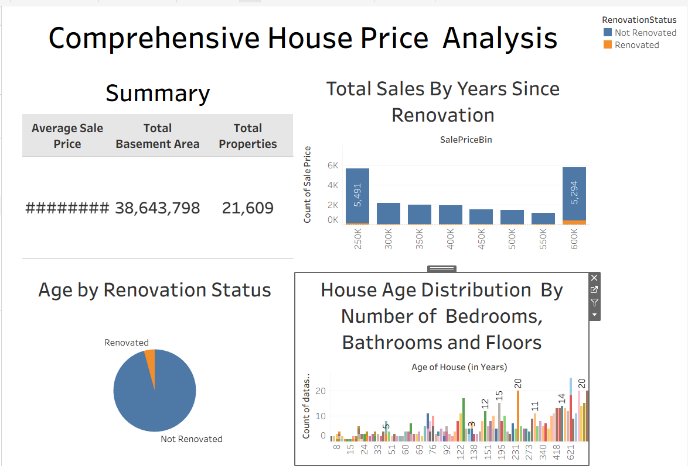

Comprehensive Housing Dashboard

It displays: - Sale price distribution by renovation status - Age and features vs price analysis - KPIs like total sales and average price Dashboard

### 8. ADVANTAGES & DISADVANTAGES

**Advantages:** - Easy-to-use visual interface - Meaningful insights from raw data

**Disadvantages:** - Dependent on internet (Tableau online) - Limited backend interaction

### 9. CONCLUSION

This project bridges the gap between data and decision-making in real estate through visualization and lightweight deployment.

### 10. FUTURE SCOPE

* Add user login and access control
* Enable real-time data syncing
* Expand to include location-based pricing

### 11. APPENDIX

* **Source Code**: app.py, index.html
* **Dataset Link**: <https://www.kaggle.com/datasets/rituparnaghosh18/transformed-housing-data-2>
* **GitHub & Project Demo Link**: <https://github.com/Vinod-chereddy/Visualizing-Housing-Market-Trends-An-Analysis-of-Sale-Prices-and-Features-using-Tableau2>